**Amazon SES**

Amazon Simple Email Service

Case Study



**Introduction**

[Amazon SES](https://aws.amazon.com/ses) is an email platform that provides an easy, cost-effective way for you to send and receive email using your own email addresses and domains.

For example, you can send marketing emails such as special offers, transactional emails such as order confirmations, and other types of correspondence such as newsletters. When you use Amazon SES to receive mail, you can develop software solutions such as email autoresponders, email unsubscribe systems, and applications that generate customer support tickets from incoming emails.

**Steps:**

Sign in Into the AWS Management Console

Search for Amazon SES Simple Email Service

Click On it and enter the dashboard.

Create Identity

* Identity details
* Emails address
* Click on Create Identity

Now you can see the status that status is unverified

Go to Your Gmail

Check mail of amazon web services and open it

By clicking on link verify your mail id

You will get this congratulation mail

Now Again check in Your Identity status in AWS SES Console

* Its Verified Now
* Now click on Send test email

Fill details of Sent test email

* Fill detail like
* From mail address
* To whom mail address
* Subject, etc.
* Mail Body

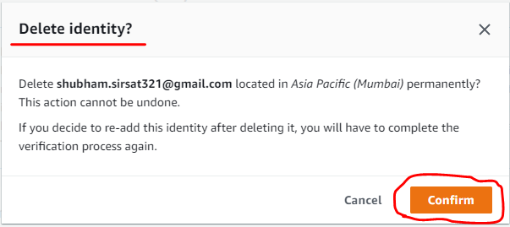

After clicking on Sent test email

Please check your Gmail account

You got one mail that we just sent from our Amazon SES service.

If you want to delete your Configuration verified identities.

Click on Delete tab

Confirm Delete

Your identity is get deleted from Amazon Simple Email Services.